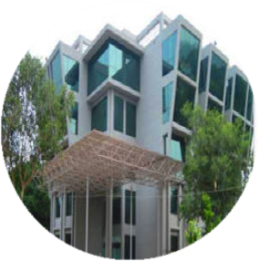

**Symposium On**

***Current Trends in Bioinformatics***

**Organised by Bioinformatics Centre (BIC)**

**CSIR-Institute of Microbial Technology, Chandigarh-160036**

**(6th November, 2015)**

**(**[**http://crdd.osdd.net/symposium/2015/**](http://crdd.osdd.net/symposium/2015/)**)**

[**Aim of Symposium**](http://crdd.osdd.net/symposium/2015/)

CSIR-IMTECH is organizing a symposium highlighting “Current Trends in Bioinformatics”. Bioinformatics is a multidisciplinary branch to develop resources, methods and software tools to explore biological data. Computational approaches provide a platform for quick and easy storage, prediction and analysis of big data before approaching bench thus reducing time and cost. The aim of this symposium is to familiarize and update the participants with the present scenario of different aspects in bioinformatics like phylogenomics, next generation sequencing (NGS), protein structure prediction; QSAR/structure based drug designing, vaccine design, viral informatics, molecular modelling and simulations, high performance computing facility etc.

**Venue**

Symposium will be organized at CSIR-IMTECH auditorium/seminar hall. All lectures would be delivered by the experts in the field.

**Who can participate?**

Science graduate/ Post graduate/ Research scholar/ Faculty member/ Scientist.

**How to pay Registration Fee:**

Registration fee is five hundred rupees (**500 INR**) for each participant. It includes tea, lunch, registration kit and certificate. **Last date of registration is** **03rd Nov. 2015**. There are three ways to pay the registration fee:-

1. **RTGS (Real Time Gross Settlement):-**

|  |  |
| --- | --- |
| Bank account number | 30267007362 |
| Bank name | STATE BANK OF INDIA |
| IFSC code | SBIN0001443 |
| MICR code | 160002017 |
| Name of account holder | Director, Institute of Microbial Technology (IMTECH) |

2. A **Demand draft** of Rs. 500/- in favour of "**Director, Institute of Microbial Technology (IMTECH)**" payable at Chandigarh towards registration fee.

3. Applicant can pay the registration fee **by cash** to Dr. Manoj Kumar at Bioinformatics Centre, CSIR-Institute of Microbial Technology during office hours (09:30AM To 05:30PM) till 03nd November 2015.

**How to apply**

For participation please fill online registration form at <http://crdd.osdd.net/symposium/2015/registration/registration.php>.

**CSIR-Institute of Microbial Technology**

Since establishment in 1984, CSIR-IMTECH has been carrying out research work in four important areas: molecular microbiology; protein science and engineering; cell biology and immunology & biochemical engineering (with particular reference to fermentative processes). IMTECH also houses several national facilities funded by Dept. of Biotechnology which include a Microbial Type Culture Collection (MTCC), (a depositary of microorganisms and vectors) and a centre for biochemical engineering in addition to Bioinformatics Centre.

**Bioinformatics Centre at CSIR-IMTECH**

Bioinformatics centre (BIC) at IMTECH, since its establishment in 1987, has shown consistent growth in different frontline areas of Bioinformatics. Centre has developed numerous databases and software, for both in-house use and researchers’ world over. BIC has developed a number of web servers based on its peer reviewed research. BIC staff has published more than 250 research papers, 75 copyrights and 150 web servers. The servers of BIC are getting more than 25000 hits per day. The centre is equipped with high performance computing from SUN and IBM besides a number of other servers. BIC is well connected by network (LAN; an internet connection; DNS; proxy).

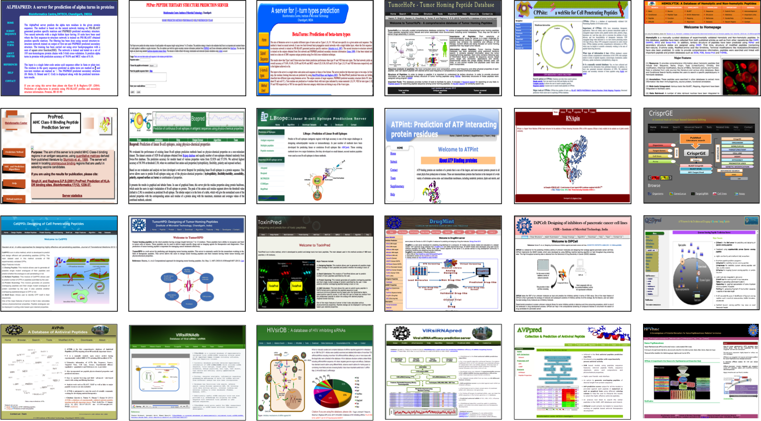

**Address for Correspondence**

**Dr. Manoj Kumar**,  
Senior Scientist, Bioinformatics Centre,   
CSIR-Institute of Microbial Technology,  
Sector 39-A, Chandigarh-160036   
Phone: 0172-6665453; 2690469, 9417552870  
Fax No. 0172-2690585, 2690632  
E-mail: manojk@imtech.res.in   
Web:<http://www.imtech.res.in/><http://www.imtech.res.in/bic/>  
          <http://crdd.osdd.net/> , http://bioinfo.imtech.res.in/